

**Course Title:** Database Systems

**Course Code:** CSE 212

**Topic Name:** UAP Soccer League Management System

**Submitted By:**

Muhammad Bin Mujib

ID: 18101017

Md. Miraj Hossain

ID: 18101022

**Index**

1. Introduction

2. ER Diagram

3. Relation

4. Schema Diagram

5. Table

6. Query

**UAP Soccer League Management System**

A football tournament is a team sport between two teams of eleven players with a spherical ball. Simply football tournament management is a web management system which store the details of player, team, coach, transfer details etc. It mostly focuses on managing all important information during the tournament season, registration process etc. during tournament and until the tournament is over. Tournament management manages the registration process before the tournament held. The system is able to register team, coaches, player, officials that are going to involve in the tournament. It manages the location and important details of each matches. It can produce pre-printed paper which been use to fill in the match result and report. The player status either eligible or suspended will state on the paper. All matches and report can be viewed by football tournament management system. Football tournament management system helps to identify the details of all the record of the team, player, coach, etc. who directly or indirectly involve in the football tournament.

**The information which are going to be available in the database are given below:**

**Table:** Club

**Attributes:** Club_id,ClubName,ClubAdd,RegistrationNo.

**Table:**Player

**Attributes:** p_id, p_name, p_position

**Table:** Club_has

**Attributes:**club_id,p_id

**Table:** individual_score

**Attributes:**p_id,score_id,goals,freekicks,pentalty,corner

**Table:**coach

**Attributes:**c_id,c_name,c_Address

**Table:**Guide

**Attributes:**club_id,c_id

**Table:**Sponsor

**Attribute:**s_id,s_name

**Table:**Supported_by

**Attributes:**Club_id,S_id

**Table:**match

**Attributes:**match_id,club_id,Date,result

**Table:**address

**Attributes:**add_code,zone,city,street

**Table:**stadium

**Attributes:**stadium_id,stadium_name

**Table:** played_at

**Attributes:**match_id,stadium_id

**ER Diagram**

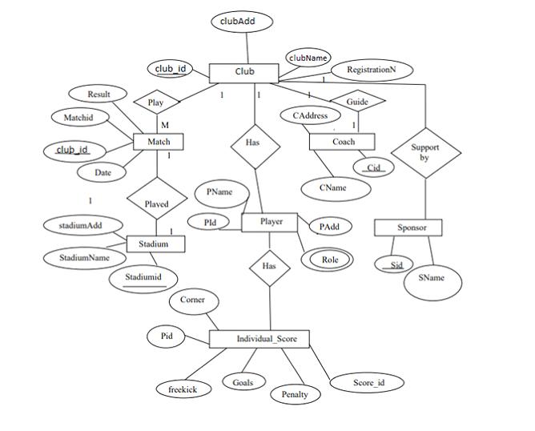

**Schema Diagram**

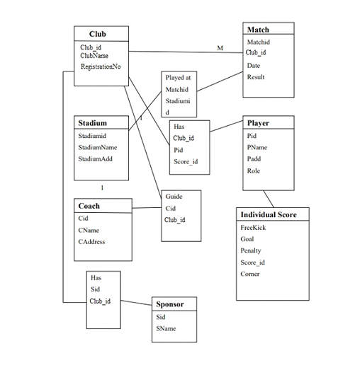

**Table**

create database Uap_Soccer_league_management_system;

Create table club

(

club_id integer not null,

clubName varchar(25)not null,

clubAdd varchar(25)not null,

RegistrationNo bigint not null,

constraint pk_club primary key(club_id)

);

Create table player

(

P_id integer not null,

P_Name varchar(25)not null,

p_position varchar(25)not null,

constraint pk_player primary key(P_id)

);

create table club_has

(

club_id integer not null,

P_id integer not null,

constraint fk_club foreign key

(club_id)references club,

constraint fk_club_has foreign key

(P_id)references player

);

create table Individual_Score

(

P_id integer not null,

score_id int,

Goals integer not null,

freekick integer not null,

penalty integer not null,

corner integer not null,

constraint fk_individual_score foreign key

(P_id) references player,

constraint pk_individual_score primary key

(score_id)

);

create table Coach

(

C_id integer not null,

C_Name varchar(25)not null,

C_Address varchar(25)not null,

constraint pk_Coach primary key(C_id)

);

create table Guide

(

club_id integer not null,

C_id integer not null,

constraint fk_guide foreign key(club_id)references club,

constraint fk_guided foreign key(C_id) references Coach

);

create table Sponsor

(

S_id integer not null,

S_Name varchar(25)not null,

constraint pk_Sponsor primary key(S_id)

);

create table support_by

(

club_id integer not null,

S_id integer not null,

constraint fk_support_by foreign key(club_id)references club,

constraint fk_supported_by foreign key(S_id)references Sponsor

);

create table match

(

Match_id integer not null,

club_id integer not null,

Date varchar(25)not null,

Result varchar(24)not null,

constraint pk_match primary key (Match_id),

constraint fk_match foreign key(club_id)references club

);

create table address

(

add_code int,

zone varchar (255),

district varchar (255),

city varchar (255),

street varchar (255),

constraint pK_address primary key(add_code)

);

create table Stadium

(

Stadium_id integer not null,

Stadium_Name varchar(25)not null,

constraint pk_Stadium primary key (Stadium_id)

);

create table Played_At

(

Match_id integer not null,

Stadium_id integer not null,

constraint fk_played foreign key(Match_id)references match,

constraint fk_played_at foreign key

(Stadium_id)references Stadium

);

alter table club drop column clubAdd;

alter table club Add c_Add int;

alter table player add P_add int;

alter table coach drop column C_Address;

alter table coach add C_add int;

-- add column stadium add

alter table stadium add Stadiumadd int;

-- add foreign key constraint

alter table stadium add

constraint fk_stadium foreign key

(Stadiumadd)references address (add_code)

drop table club;

drop table player;

drop table club_has;

drop table Individual_Score;

drop table Coach;

drop table Guide;

drop table Sponsor;

drop table support_by;

drop table match;

drop table Stadium;

drop table Played_At;

drop table address;

--inserting data into table club

insert into[dbo].[club]

values

(01,'CSE4.2',123451,1023),

(02,'CSE4.1',123452,1024),

(03,'CSE3.2',123453,1025),

(04,'CSE3.1',123454,1026),

(05,'CSE2.2',123455,1027),

(06,'CSE2.1',123456,1028),

(07,'CSE1.2',123457,1029),

(08,'CSE1.1',123458,1030);

--inserting data into table player

insert into [dbo].[player]

values

(10,'Tanvir','Goalkeeper',1040),

(11,'Binmujib','Centermidfield',1041),

(12,'Miraz','center-forward',1042),

(13,'Mashfi','Second -striker',1043),

(14,'Rumman','Winger',1044),

(15,'Akash','Winger',1045),

(16,'Prodhan','Winger',1046),

(17,'Rafsan','center-forward',1047),

(18,'Rakin','center-forward',1048),

(19,'Nafees','Goalkeeper',1049),

(20,'joy','Centermidfield',1050),

(21,'Soumik','Centermidfield',1051),

(22,'Sadman','Winger',1052),

(23,'Rouf','Winger',1053),

(24,'Muhammad','Winger',1054),

(25,'Adib','Winger',1055),

(26,'Mridul','Centermidfield',1056),

(27,'Tasin','Winger',1057),

(28,'Sarvi','Winger',1058),

(29,'Fahim','Goalkeeper',1059),

(30,'Ahmed','Winger',1060),

(31,'Rimon','Winger',1061),

(32,'Ifty','Centermidfield',1062),

(33,'Antik','Winger',1063),

(34,'Aknit','Goalkeeper',1064),

(35,'Sudip','Winger',1065),

(36,'Mahadi','center-forward',1066),

(37,'Hasan','Winger',1067),

(38,'Rumi','Winger',1068),

(39,'Yasin','Winger',1069),

(40,'Arafat','Winger',1070),

(41,'Rafin','Winger',1071),

(42,'Emon','Winger',1072),

(43,'Andalib','center-forward',1073),

(44,'Zubayer','Winger',1074),

(45,'Kamal','Winger',1075),

(46,'Muzahid','Winger',1076),

(47,'Azad','Winger',1077),

(48,'Shommo','Winger',1078),

(49,'Anik','center-forward',1079),

(50,'Ahnaf','Winger',1080),

(51,'Atif','Winger',1081),

(52,'Moin','Centermidfield',1082),

(53,'Asad','Winger',1083),

(54,'Galib','Winger',1084),

(55,'Imam','Winger',1085),

(56,'Omit','center-forward',1086),

(57,'Noor','Winger',1087),

(58,'Navil','Winger',1088),

(59,'Nabil','Winger',1089),

(60,'Samad','Winger',1089),

(61,'Saad','center-forward',1090),

(62,'Jamal','Winger',1091),

(63,'Topon','Winger',1092),

(64,'Topu','Goalkeeper',1093),

(65,'Anis','center-forward',1094),

(66,'Motin','Winger',1095),

(67,'Mia','Winger',1096),

(68,'John','Winger',1097),

(69,'Sunil','center-forward',1098),

(70,'Hady','Winger',1099),

(71,'Raiyan','Winger',1100),

(72,'Radin','Winger',1101),

(73,'Saki','Winger',1102),

(74,'Sadi','Goalkeeper',1103);

--inserting data into table club_has

insert into[dbo].[club_has]

values

(01, 10),

(01, 11),

(01, 12),

(01, 13),

(01, 14),

(01, 15),

(01, 16),

(01, 17),

(02, 18),

(02, 19),

(02, 20),

(02, 21),

(02, 22),

(02, 23),

(02, 24),

(02, 25),

(03, 26),

(03, 27),

(03, 28),

(03, 29),

(03, 30),

(03, 31),

(03, 32),

(03, 33),

(04, 34),

(04, 35),

(04, 36),

(04, 37),

(04, 38),

(04, 39),

(04, 40),

(04, 41),

(05, 42),

(05, 43),

(05, 44),

(05, 45),

(05, 46),

(05, 47),

(05, 48),

(05, 49),

(06, 50),

(06, 51),

(06, 52),

(06, 53),

(06, 54),

(06, 55),

(06, 56),

(06, 57),

(07, 58),

(07, 59),

(07, 60),

(07, 61),

(07, 62),

(07, 63),

(07, 64),

(07, 65),

(08, 66),

(08, 67),

(08, 68),

(08, 69),

(08, 70),

(08, 71),

(08, 72),

(08, 73);

--inserting data into individual_score

insert into [dbo].[Individual_Score]

values

('10','501','1','0','0','0'),

('11','502','2','0','0','0'),

('12','503','5','0','0','0'),

('13','504','5','0','0','0'),

('14','505','4','0','0','0'),

('15','506','9','0','0','0'),

('16','507','2','0','0','0'),

('17','508','5','0','0','0'),

('18','509','3','0','0','0'),

('19','510','7','0','0','0'),

('20','511','2','0','0','0'),

('21','512','7','0','0','0'),

('22','513','9','0','0','0'),

('23','514','8','0','0','0'),

('24','515','4','0','0','0'),

('25','516','4','0','0','0'),

('26','517','1','0','0','0'),

('27','518','8','0','0','0'),

('28','519','0','0','0','0'),

('29','520','8','0','0','0'),

('30','521','5','0','0','0'),

('31','522','0','0','0','0'),

('32','523','4','0','0','0'),

('33','524','0','0','0','0'),

('34','525','8','0','0','0'),

('35','526','7','0','0','0'),

('36','527','1','0','0','0'),

('37','528','7','0','0','0'),

('38','529','0','0','0','0'),

('39','530','0','0','0','0'),

('40','531','5','0','0','0'),

('41','532','7','0','0','0'),

('42','533','9','0','0','0'),

('43','534','8','0','0','0'),

('44','535','4','0','0','0'),

('45','536','4','0','0','0'),

('46','537','1','0','0','0'),

('47','538','8','0','0','0'),

('48','539','0','0','0','0'),

('49','540','8','0','0','0'),

('50','541','5','0','0','0'),

('51','542','5','0','0','0'),

('52','543','5','0','0','0'),

('53','544','4','0','0','0'),

('54','545','9','0','0','0'),

('55','546','2','0','0','0'),

('56','547','5','0','0','0'),

('57','548','3','0','0','0'),

('58','549','7','0','0','0'),

('59','550','2','0','0','0'),

('60','551','7','0','0','0'),

('61','552','9','0','0','0'),

('62','553','9','0','0','0'),

('63','554','8','0','0','0'),

('64','555','4','0','0','0'),

('65','556','4','0','0','0'),

('66','557','1','0','0','0'),

('67','558','8','0','0','0'),

('68','559','0','0','0','0'),

('69','560','8','0','0','0'),

('70','561','5','0','0','0'),

('71','562','0','0','0','0'),

('72','563','4','0','0','0'),

('73','564','0','0','0','0');

--inserting data into table coach

insert into [dbo].[Coach]

values

(101,'Sakib','1015'),

(102,'Rabbi','1016'),

(103,'Sopon','1017'),

(104,'Aloke','1018'),

(105,'Nadeem','1019'),

(106,'Imran','1020'),

(107,'Murad','1021'),

(108,'Nahian','1022');

--inserting data into table guide

insert into [dbo].[Guide]

values

(01, 101),

(02, 102),

(03, 103),

(04, 104),

(05, 105),

(06, 106),

(07, 107),

(08, 108);

--inserting data into table Sponsor

insert into[dbo].[Sponsor]

values

(201,'Acer'),

(202,'DELL'),

(203,'SAMSUNG'),

(204,'HP'),

(205,'Asus'),

(206,'Xaiomi'),

(207,'LG'),

(208,'Walton');

--inserting data into table support_by

insert into [dbo].[support_by]

values

(01,201),

(02,202),

(03,203),

(04,204),

(05,205 ),

(06,206),

(07,207),

(08,208);

--inserting data into table match

insert into [dbo].[match]

values

(301,04,'1st June','Won'),

(302,03,'3rd June','Won'),

(303,01,'5th June','Lose'),

(304,02,'8th June','Lose'),

(305,05,'15th Jun','Won'),

(306,06,'18th June','Lose'),

(307,07,'25th Jun','Won'),

(308,07,'25th Jun','Won');

--inserting data into table Played_At

insert into [dbo].[Played_At]

values

(301,401),

(302,402),

(303,403),

(304,404),

(305,405),

(306,403),

(307,405),

(308,402);

--inserting data into table Stadium

insert into [dbo].[Stadium]

values

(401,'MirpurGround','1010'),

(402,'FarmgateGround ','1011'),

(403,'PurbachalGround','1012'),

(404,'MujibGarden','1013'),

(405,'LordMirazGround','1014');

--Stadium address

insert into address values

(1010,'Dhaka','Dhaka','Mirpur','OceanRoad'),

(1011,'Dhaka','Dhaka','Farmgate','greenroad'),

(1012,'Dhaka','Dhaka','Purbachal','Yellowroad'),

(1013,'Dhaka','Dhaka','Mirpur','blueroad'),

(1014,'Dhaka','Dhaka','Dhanmondi','whiteroad');

--Coach Addres

insert into address values

(1015,'Dhaka','Savar','Savar','BazarRoad'),

(1016,'Chittagong','Noakhali','Maijdee','GaneshMandir'),

(1017,'Khulna','Bagherhat','Khanjhan','MangalBazar'),

(1018,'Rangpur','rangpur','uttam','sumoroad'),

(1019,'Dhaka','Dhaka','Mirpur','Shankhamul'),

(1020,'sylhet','srimongal','sunamgonj','Sonapur'),

(1021,'Kamrangichor','purba','Rasulpur','7no.goli'),

(1022,'Noakhali','laxmipur','Ramgonj','kanchanpur');

--club address

insert into address values

(1023,'Dhaka','Dhaka','Mirpur','Kajipara'),

(1024,'Dhaka','Dhaka','farmgate','Greenroad'),

(1025,'Dhaka','Dhaka','Purbachal','kajibari'),

(1026,'Dhaka','Dhaka','Dhanmondi','lake'),

(1027,'Dhaka','Dhaka','Gulistan','CampusGate'),

(1028,'Dhaka','Dhaka','Purbachal','kajibari'),

(1029,'Dhaka','Dhaka','Dhanmondi','lake'),

(1030,'Dhaka','Dhaka','Gulistan','CampusGate');

select * from [dbo].[club]

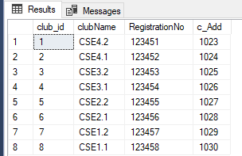

select * from [dbo].[address]

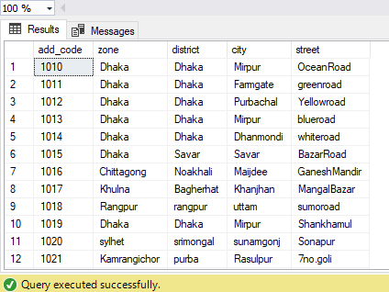

select * from [dbo].[club_has]

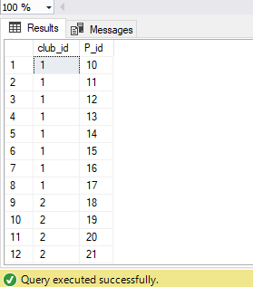

select * from [dbo].[Coach]

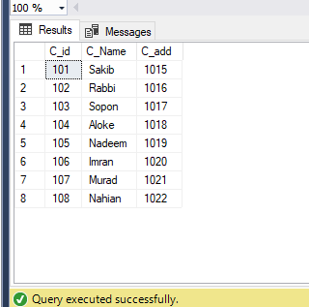

select * from [dbo].[Guide]

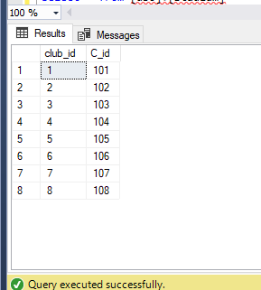

select * from [dbo].[Individual_Score]

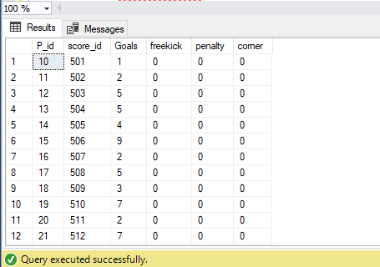

select * from [dbo].[match]

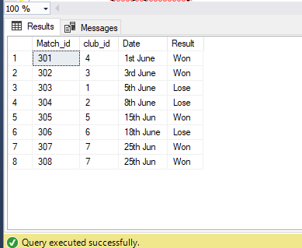

select * from [dbo].[Played_At]

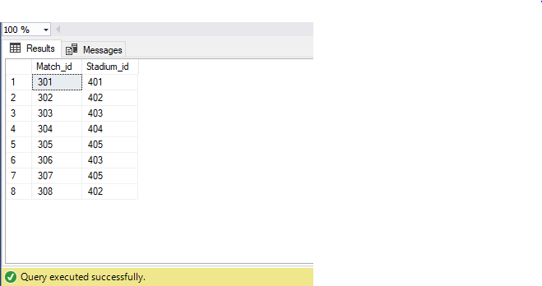

select * from [dbo].[player]

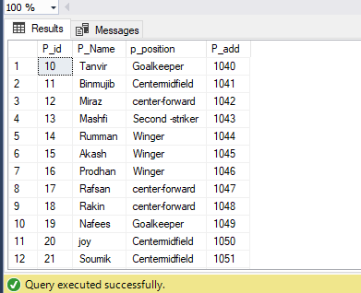

select * from [dbo].[Sponsor]

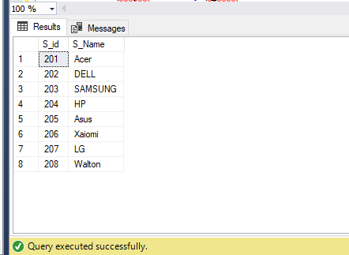

select * from [dbo].[Stadium]

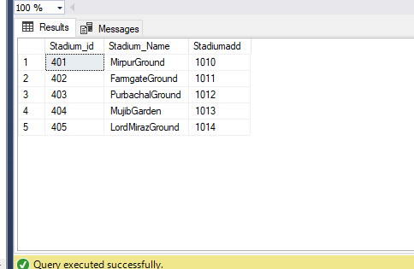

select * from [dbo].[support_by]

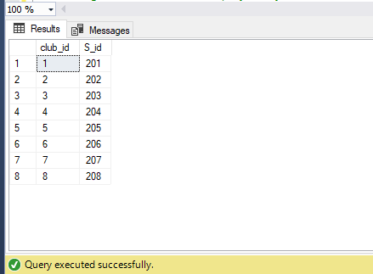

**Query**

--1.Arrange all the details of players by their name in discending

select * from player order by p_name desc

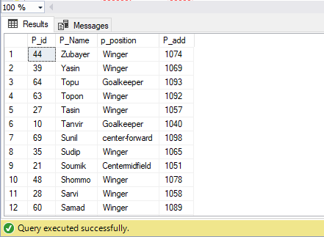

--2.Arrange all the details of players by their name in ascending

select * from player order by p_name asc

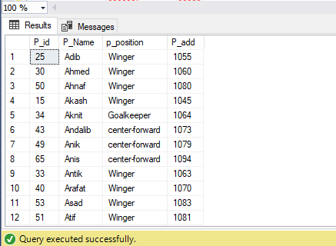

--3.Retrieve all detail of club with id 05

select*from club where club_id=05

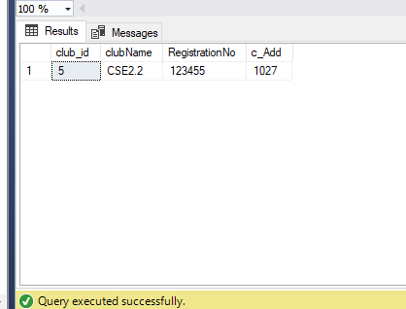

--4.Retrieve name of player whose address is =1042

select * from player where p_add=1042

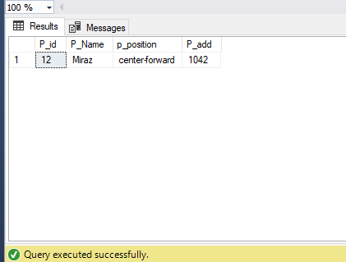

--5.Retrieve the name of the player who is in club CSE 4.1

select p_name

from player ,club_has,club

where player.p_id=club_has.p_id and club_has.club_id=club.club_id and clubName ='CSE4.1';

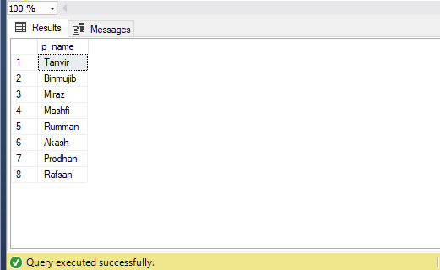

--6.Retrieve all match detail with match id between 301 and 307

Select*

from match

where match_id between 301 and 307;

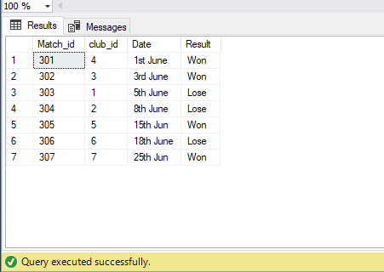

--7.Retrieve all the details of coaches

select * from coach order by c_name desc

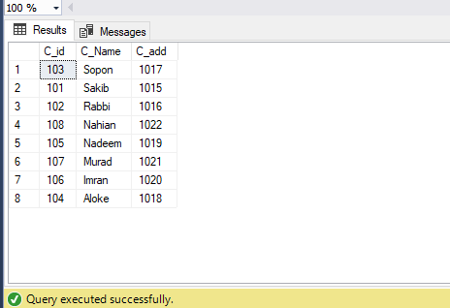

--8.Retrieve all the details of Sponsors

select * from sponsor order by s_name desc

